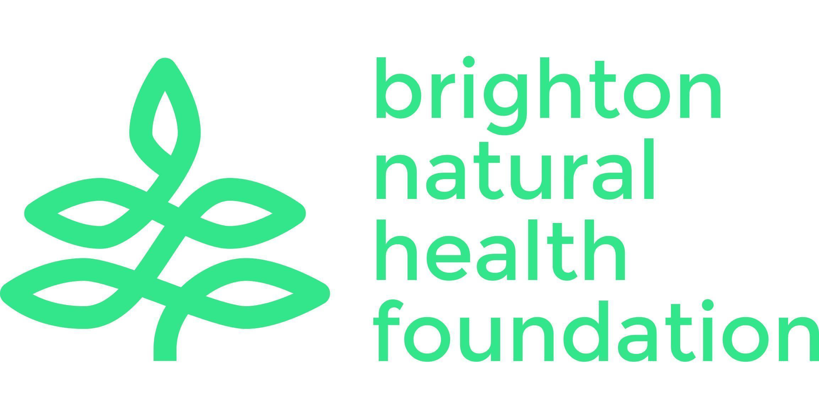
Brighton Natural Health Foundation Limited
Community Base 113 Queens Road Brighton BN1 3XG
hello@bnhf.org | www.bnhf.org
company no. 1836964
registered charity no. 290122

Healthy Communities Healthy City Healthy Planet

Chair of Trustees Application Pack

About the charity
Who we are
At Brighton Natural Health foundation (‘BNHF’, the ‘Charity’), our mission is to reduce health inequalities in Brighton and Hove by providing free and inclusive mindful movement classes to people who are least able to access them. We work with people facing physical or mental health difficulties, marginalised communities and people facing economic disadvantage to make the city
a happier and healthier place to live.
Mindful movement practices such as yoga, tai chi, qigong and Pilates have proven and profound benefits for physical and mental health. Our community-based classes introduce people to these benefits in a supportive, welcoming environment

Our history
Brighton Natural Health Centre (BNHC) was founded by Infinity Foods in 1981” to promote and advance the education of the public in the field of healthcare, nutrition and related subjects”.

The focus was promoting the benefits of all-round health for body, mind and planet. For more than 40 years we provided a range of low-cost, accessible health and wellbeing classes in our Brighton studio – including yoga, Pilates, ballet and dance, meditation and relaxation techniques, and much more.

We also ran an outreach programme delivering free or low-cost community classes for young adults with learning difficulties and people experiencing homelessness; female refugees, migrants and asylum seekers; and trauma-informed yoga classes for women in Brighton and Hove.

New direction
When the Centre opened in 1981, it was the only such place in the city. Over four decades later, BNHC’s pioneering work has helped spark a revolution which has seen many studios and natural health organisations proliferate in the city centre.

Yet, access to these life-changing classes is often limited to wealthier parts of the city - an expensive bus ride away from the more disadvantaged areas. Studios charge up to £16 per session, making regular classes impossible for many. Participants also tell us they often feel unwelcome and worried they don’t have the “right” body type, flexibility, or clothing.

To meet this new challenge, we closed our central studio in 2023 and began to focus all our efforts and expertise on developing mindful movement classes in areas of the city facing the greatest health disadvantages. We changed our name to Brighton Natural Health Foundation to reflect this new direction. Last year we merged with the award-winning Brighton Yoga Foundation, a local charity with similar aims, to help us meet our shared goals more efficiently.

The need we are addressing
Nationally, people are spending more of their lives in ill-health and the gap in healthy life expectancy between the poorest and richest is growing. This is mirrored in our city where health inequalities are stark and troubling with men in the most deprived areas dying nine years younger than those in more affluent areas. The gap in healthy life expectancy is even greater and conditions like heart disease, diabetes hypertension, COPD, chronic pain, anxiety and depression place a heavy burden on communities.

An ever-growing research base shows that mindful movement benefits all of these conditions.
It also helps people make lifestyle changes which can lead to healthier choices and long-term change. However, people facing health inequalities face barriers to accessing classes including cost, accessibility and a perception that mindful movement is simply not for them.

Against this backdrop of deteriorating health outcomes, we see a clear need for BNHF in terms of helping shape the wellbeing of Brighton and Hove’s residents who are struggling with their mental, physical and social health.

Our new direction is in line with the Labour government’s proposed 10 Year Health Plan to be published in 2025, which signals a strong shift towards prevention. In addition, we meet regularly with the city’s public health team to ensure we are working towards their strategic goals of encouraging people to move more and to improve physical and mental wellbeing.

Our goals
BNHF is repositioning itself as a trusted source of teaching, expertise, advice and training to become the focal point for all mindful movement and related practices within the city. To do this,
we will:
- Expand our mindful movement classes in the areas facing the greatest health inequalities
- Work with local residents to ensure these classes meet their needs and wishes
- Develop strong relationships with voluntary and statutory agencies
- Position ourselves as a key referral partner within the NHS’s local ‘social prescribing’ model
- Raise awareness of the benefits of mindful movement to a wider audience
- Provide training to practitioners ensuring they are offering safe, accessible and inclusive classes
- Establish ourselves as a source of expertise in the field of mindful movement and health inequalities
- Offer rewarding volunteering opportunities

Partners and supporters
We are working with a wide range of partners including:
- The Council’s Public Health Healthy Lifestyle Team who we are meeting with monthly
to ensure that we are fitting in with their strategic vision
- Social prescribers, primary care networks and other NHS bodies throughout the city
- Community & Voluntary Sector – we work closely with the Trust for Developing Communities, the Hangleton and Knoll Project, The Carers Centre, Rise, Together Co
- Eco-therapy: Lovebrook Farm are supporting the project and we also hope to collaborate with the Green Well-Being Alliance and the Brighton and Hove Food Partnership

Introduction to the Chair of Trustees role
Over the last 18 months we have been on a journey of change and transformation to ensure that we are a resilient and sustainable charity, able to develop and adapt. With our current interim Chair stepping down, we are seeking a new Chair who will lead us through our next chapter. You will be joining BNHF at an exciting time as we embark on our strategy for the next few years.

We are looking for an active and engaged Chair who can provide the leadership and guidance needed to achieve our ambitions. You will play a leadership role both within the Charity itself and
in championing our mission to the outside world.

You will be joining and leading a committed, experienced and skilled Board and a dynamic and forward-looking organisation, and with the opportunity and ability to influence our future. Our Board of Trustees makes key decisions about the direction of the organisation and how we achieve our purpose. They also make sure that BNHF has the resources and policies it needs to do this well and to comply with legal requirements.

If you share our enthusiasm for tackling health inequalities, developing mental, physical and social health in the community, enjoy thinking strategically and working collaboratively, and can bring diverse professional and personal experience to our Board, then we’d love to hear from you.

The organisation and the Board are committed to learning around EDI and are dedicated to a continuous process of challenging ourselves to increase inclusivity across every area of our work. We welcome applications from all sections of society.

This is an unpaid role but we can offer reimbursement of reasonable expenses incurred in undertaking your volunteer role as a Chair.

Role description
As our new Chair you will help shape the next exciting phase of our future development as we develop our strategic business plan and embed our newest Trustees within our established Board.

The overall role of the Chair is to lead the Board as it sets strategic direction and oversee the good governance of the Charity, and ensure it is meeting its charitable obligations.

The Chair also leads the small management team, providing guidance, oversight and performance management, and assists with certain business management activities as necessary.

The Chair and Board have the support of a Board secretary responsible for the smooth running
of meetings and the various sub-committees (chaired by other trustees) that deal with specific aspects of the Charity’s activities

This is an active role, where time will need to be invested regularly outside of meetings to support the work of the Board and the Charity.

The role of the Chair includes the following:
- Providing strategic leadership to the Charity, the Board and senior management, ensuring that BNHF achieves its mission, promoting a culture of openness and debate
- Developing the Board of Trustees including induction, training and succession planning
- Ensuring the Board and management team develop, and work to, high standards of governance and risk management
- Ensuring sound financial oversight, including review and approval of the annual budget
- Undertaking certain business management activities (such as payroll, HR, legal and banking matters) as required. This may be to ensure confidentiality or to assist other Trustees or the operations team who are normally responsible for such activities
- Preparing, chairing and facilitating Board meetings including encouraging discussion, summarising key points and ensuring decisions are made and implemented
- Taking urgent action between Board meetings when it isn’t possible or practical to hold
a meeting
- Undertaking line management of the small operations team who provide management responsibility on a day-to-day basis
- Developing relationships with key stakeholders including community organisations, the Council, health services, corporate partners, and other charities in related areas of work
- Acting as a spokesperson, ambassador and figurehead for the Charity

Skills, qualities and experience
You don’t need to have specific previous experience on a charity board to apply for the role of Chair. We recognise that many of the skills required are transferable, and you may have gained them in other settings or through other relevant experience. Understanding or experience of the mental, physical and social health sector is highly desirable. Desired skills include:
- Significant experience of leadership and team-working in a senior management role in
a non-profit or commercial organisation
- An inclusive leadership style, able to inspire and support everyone to participate on an
equal footing
- The ability to listen and engage effectively. Comfortable with challenge and debate and
able to encourage that in others whilst fostering a collaborative Board environment
- The ability to oversee and direct the legal duties and responsibilities of a Board of Trustees
- Sound judgement, good analytical skills and a keen sense of strategic purpose
- Being responsive - as a small charity, things sometimes ‘come up’ that require the Chair
to advise, support or authorise. It is very helpful to have a Chair who is available and responsive
- Excellent communication and public speaking skills, and a willingness to advocate for and champion BNHF’s work through personal networks,
social media, and other channels
- The ability to use digital technology in order to participate in Trustee activities online
- A commitment to Nolan’s seven principles of public life: selflessness, integrity, objectivity, accountability, openness, honesty and leadership
- Energy and enthusiasm and a strong commitment to promoting equality and social justice

In addition to the above, the Chair will have the general responsibilities and qualities of all Trustees as set out in the Trustee Role Description, some of which will overlap. (see appendix below)

Time commitment
The key Chair responsibilities are likely to require up to 2 days per month including attending
4-5 in-person or virtual Board meetings per year, sub-committees where relevant and an annual strategy event with the Board and management team. There may be an additional time commitment to review meeting papers which are circulated in advance of Board and committee meetings. Attending some activities organised by BNHF where possible.

Term of office
All Trustees including the Chair are appointed for an initial three-year term of office and may stand for re-election after this period.

How to apply
Please submit an expression of interest in your preferred format – written statement, video, etc. – telling us:
- Why you would like to lead the Board of Trustees at BNHF
- How your skills and experience match what we are looking for in a new Chair

Please also include your CV and complete the Equal Opportunities Monitoring Form. This won’t be seen by the panel but helps us to ensure that we are inclusive in our advertising and recruitment, and to understand the diversity of our Board.

Please email your application to chair@bnhf.org by 5pm on 4 April 2025.

We will respond to you promptly and interviews will be held soon after this date.

Appendix: Trustee role description
Our Trustees play a vital role in making sure that BNHF achieves its core purpose. They oversee the overall management and administration of the Charity. They also ensure that BNHF has a clear strategy and that our work and goals are in line with our vision.

Just as importantly, they support and challenge the management team to enable us to grow and thrive, and through this, achieve our mission. They also make sure that BNHF has the resources and policies it needs to do this well and to comply with legal requirements.

Board members have a collective responsibility. This means that Trustees act as a group and not as individuals, except when undertaking specific delegated activities on a voluntary basis. The Board aims to have a mix of people with experience of the natural health sector as well as people with a range of other life experiences.

The formal responsibilities of a trustee are:
- To ensure that the Charity is carrying out its purposes for the public benefit
- To comply with the Charity’s governing document and the law
- To act in the Charity’s best interests
- To manage the Charity’s resources responsibly
- To act with reasonable care and skill
- To ensure that the Charity is accountable

The trustee’s role is to support and provide advice on BNHF’s purpose, vision, goals and activities, including to:
- Attend Board meetings, adequately prepared to contribute to discussions. Contribute to regular reviews of governance
- Approve operational strategies and policies and monitor and evaluate their implementation
- Ensure the effective and efficient administration of the organisation
- Ensure that key risks are being identified, monitored and controlled effectively
- Review and approve BNHF’s financial statements
- Oversee financial plans and budgets and monitor and evaluate progress.
- Provide support and challenge to the management team in the exercise of their delegated authority and activities
- Keep abreast of changes in our operating environment
- Use independent judgment, acting legally and in good faith to promote and protect BNHF’s interests, to the exclusion of their own personal and/or any third-party interests
- Contribute to the broader promotion of BNHF’s objects, aims and reputation by applying
your skills, expertise, knowledge and contacts

